Mathematics Lab

Sumukh Santhosha Kesarla

Enrolment Number: 200031101611057

Date:

clc

clear

A = [4 5 8 6]

disp(A)

B = [4;7;2;6]

disp(B)

C = [1 2 3 ; 2 4 6 ; 3 6 9 ]

disp(C)

D = [4 5 8; 2 3 6; 9 5 7]

disp(D)

disp(C(:,3))

disp(det(C))

disp(inv(C))

disp(rank(C))

disp(trace(C))

E = C + D

disp(E)

F = C * D

disp(F)

disp(6*C)

—-------------------------------------------------

clc

clear

v1 = [2 2 1]

v2 = [1 -1 1]

V3 = [1 0 1]

v = [v1; v2; v3]

disp(v)

r = rank(v)

if r == 3 then

disp "it is Linearly Inependent"

else

disp "It is Lineraly dependent"

end

—--------------------------------------------------

clc

clear

v1 = [1 2 3 1]

v2 = [2 1 -1 1]

v3 = [4 5 5 3]

v4 = [5 4 1 3]

v = [v1; v2; v3; v4]

disp(v)

[row c] = size(v)2

r = rank(v)

if r == row then

disp "it is Linearly Inependent"

else

disp "It is Lineraly dependent"

end

—------------------------------------------------------

clc

clear

v1 = [2 -3 1]

v2 = [1 -1 2]

v3 = [2 1 -3]

v=[v1; v2; v3]

disp(v)

c = [-2;3;-2]

disp(c)

X = inv(v) * c

Y = v*X - c

if Y == zeros(Y) then

disp(X)

else

disp("System is inconsistent")

end

—---------------------------------------

Date: 05/04/2022

1. By using SCILAB to determine whether or not the vectors $\left(1, -2, 1\right),\left(2, 1, -1\right), \left(7, -4, 1\right)$ are linearly dependent and solve the following system of linear equations:

2x-3y+z=-2, x-y+2z=3, 2x+y-3z=-2.

clc

clear

v1 = [1 -2 1]

v2 = [2 1 -1]

v3 = [7 -4 1]

v = [v1; v2; v3]

ra = rank(v)

[row c] = size(v)

if ra == row then

disp("Vectors are Linearly Independent")

else

disp("Vectors are Linearly Dependent")

end

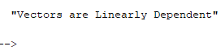

clc

clear

a1 = [2 -3 1]

a2 = [1 -1 2]

a3 = [2 1 -3]

a = [a1; a2; a3]

b = [-2; 3; -2]

x = inv(a) * b

disp(x)



1. Write the given system of equation in matrix form.

2x1+2x2-5x3=1, -2x1+4x2+3x3=6, -x1+3x2+2x3=5 and solve it for finding the values of xi’s.

clc

clear

a1 = [2 2 -5]

a2 = [-2 4 3]

a3 = [-1 3 2]

a = [a1; a2; a3]

b = [1; 6; 5]

x = inv(a) * b

disp(x)

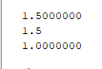

1. For a given matrix A=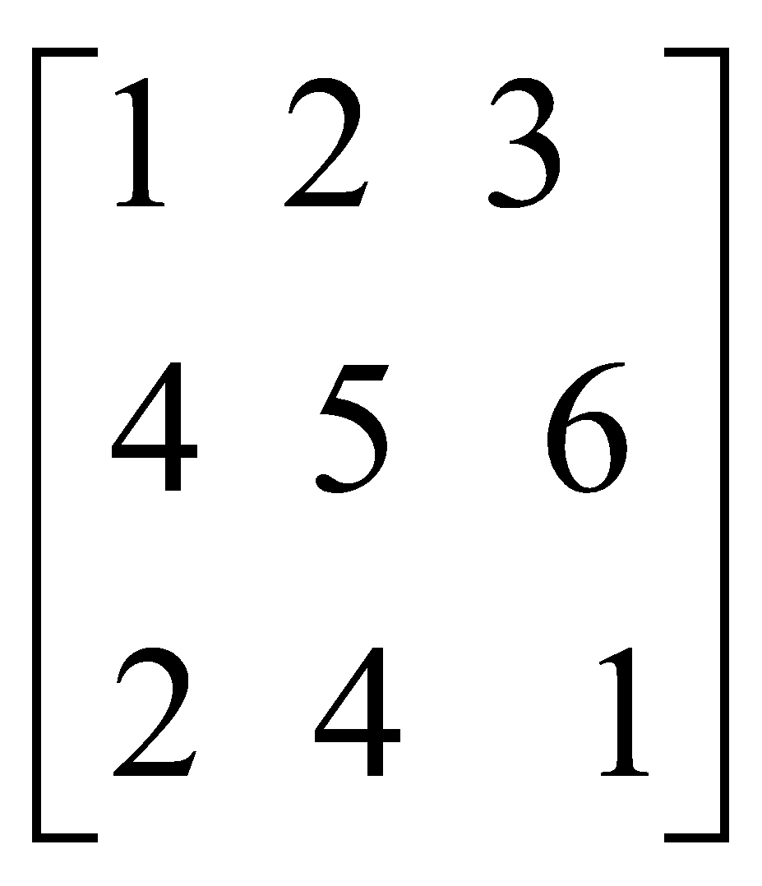 , find (a)Inverse(A) (b)Det.(A) (c)Trace (d) rank(A)

clc

clear

a = [1 2 3; 4 5 6; 2 4 1]

disp("inverse of A is: ")

disp(inv(a))

disp("Determinant of A is: ")

disp(det(a))

disp("Trace of A is: ")

disp(trace(a))

disp("Rank of A is: ")

disp(rank(a))

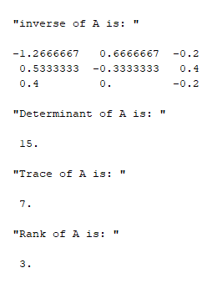

1. Write the given system of equation in matrix form.

2x1+2x2-5x3=1, -2x1+4x2+3x3=6, -x1+3x2+2x3=5 and solve it for finding the values

ofxi’s.

clc

clear

a1 = [2 2 -5]

a2 = [-2 4 3]

a3 = [-1 3 2]

a = [a1; a2; a3]

b = [1; 6; 5]

x = inv(a) * b

disp(x)



1. Given two Matrices as

A=[1 2 3; 4 5 6; 2 4 1], B=[2 3 4; 6 7 8; 9 7 4]

Write (a)inverse (b)rank (c) trace and determinant of a matrices.

clc

clear

a=[1 2 3; 4 5 6; 2 4 1]

b=[2 3 4; 6 7 8; 9 7 4]

disp("inverse of A is: ")

disp(inv(a))

disp("Determinant of A is: ")

disp(det(a))

disp("Trace of A is: ")

disp(trace(a))

disp("Rank of A is: ")

disp(rank(a))

disp("inverse of B is: ")

disp(inv(b))

disp("Determinant of B is: ")

disp(det(b))

disp("Trace of B is: ")

disp(trace(b))

disp("Rank of B is: ")

disp(rank(b))

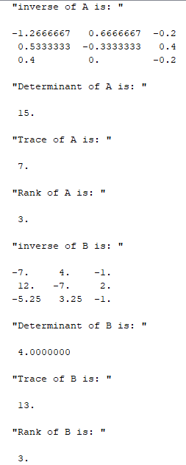

1. Solve the system of equation with the help of SciLab, finding the values of x,y,z-

$2x+3y+4z=11$, $x+5y+7z=15, 3x+11y+13z=25$.

clc

clear

a1 = [2 3 4]

a2 = [1 5 7]

a3 = [3 11 13]

a = [a1; a2; a3]

b = [11; 15; 25]

x = inv(a) * b

disp(x)

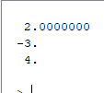

1. Check for Linear independency/ dependency for the given set of vectors using SciLab-

[1,2,3] [3,4,4] [7,10,12]

clc

clear

a1 = [1,2,3]

a2 = [3,4,4]

a3 = [7,10,12]

a = [a1; a2; a3]

ra = rank(a)

[row c] = size(a)

if ra == row then

disp("Vectors are Linearly Independent")

else

disp("Vectors are Linearly Dependent")

End

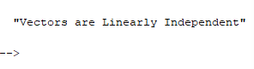

1. Find trace, determinant and rank of matrix A=[1, 2, 3; 2, 0,-1; 0, 0, 3].

clc

clear

A = [1, 2, 3; 2, 0,-1; 0, 0, 3]

disp("Trace of B is: ")

disp(trace(A))

disp("Determinant of B is: ")

disp(det(A))

disp("Rank of B is: ")

disp(rank(A))

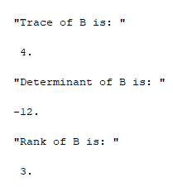

1. Solve the following system of linear equations:

(i)2x-3y+z=-2, x-y+2z=3, 2x+y-3z=-2

clc

clear

a1 = [2 -3 1]

a2 = [1 -1 2]

a3 = [2 -1 3]

a = [a1; a2; a3]

b = [-2; 3; -2]

x = inv(a) * b

disp(x)



(ii)X+4y+7z=1, 2x+5y+8z=2, x+2y+3z=1

clc

clear

a1 = [1 4 7]

a2 = [2 5 8]

a3 = [1 2 3]

a = [a1; a2; a3]

b = [1; 2; 1]

x = inv(a) * b

disp(x)

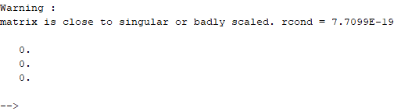

(iii)x-4y+7z=8, 3x+8y-2z=6, 7x-8y+26z=3

clc

clear

a1 = [1 -4 7]

a2 = [3 8 -2]

a3 = [7 -8 26]

a = [a1; a2; a3]

b = [8; 6; 3]

x = inv(a) * b

disp(x)

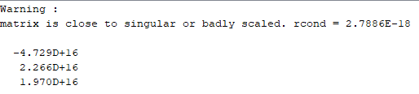0.

Date: 12/04/2022

1. To solve: (dy/dx)=x+y, y(0)=1, when x=[0,1]

clc

clf

clear

function [**ydot**]=myfunction(**x**, **y**)

**ydot** = **x**+**y**

endfunction

x1 = 0

y1 = 1

x = linspace(0,1,100)

y = ode(y1, x1, x, myfunction)

disp(x,y)

plot(x,y)  
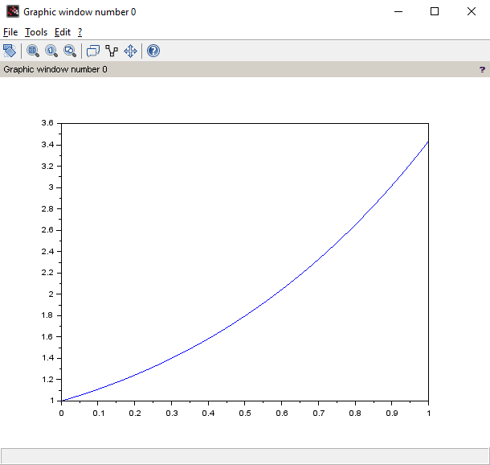

1. Write a scilab code to find solution of the first order initial value problem at x=0.8:
2. Solve and Plot the solution: (dx/dt)+(tant)x=cost, y(0)=0 ; in interval [0,1]

clc

clf

clear

function [**tdot**]=myfunction(**x**, **t**)

**tdot** = cos(**t**) - **x**\*tan(**t**)

endfunction

x1 = 0

y1 = 0

x = linspace(0,1,100)

y = ode(y1, x1, x, myfunction)

disp(x,y)

plot(x,y)

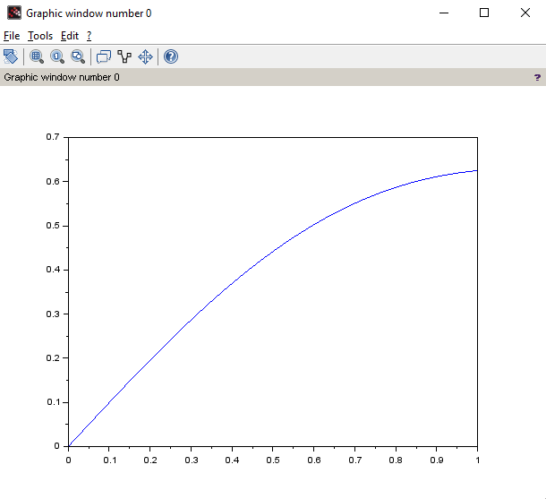

1. 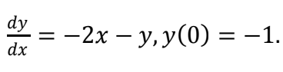

clc

clf

clear

function [**ydot**]=myfunction(**x**, **y**)

**ydot** = -2\***x** - **y**

endfunction

x1 = 0

y1 = -1

x = linspace(0,1,100)

y = ode(y1, x1, x, myfunction)

disp(x,y)

plot(x,y)

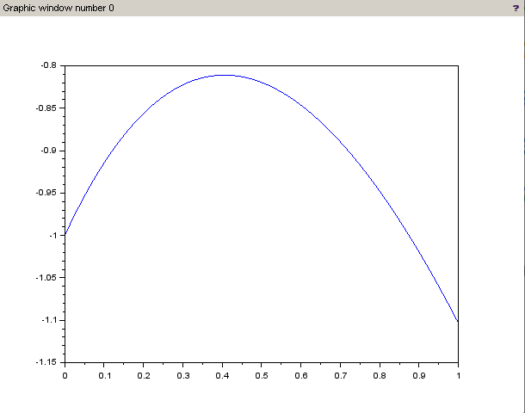

1. 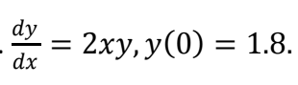

clc

clf

clear

function [**ydot**]=myfunction(**x**, **y**)

**ydot** = 2\***x**\***y**

endfunction

x1 = 0

y1 = 1.8

x = linspace(0,1,100)

y = ode(y1, x1, x, myfunction)

disp(x,y)

plot(x,y)

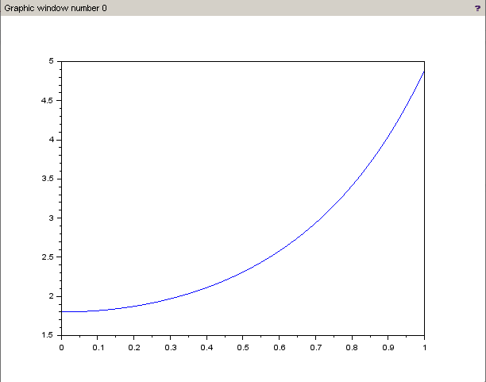

1. 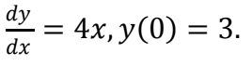

clc

clf

clear

function [**ydot**]=myfuntion(**x**, **y**)

**ydot** = 4\***x**

endfunction

x1 = 0

y1 = 3

x = linspace(0,1,100)

y = ode(y1, x1, x, myfuntion)

disp(x,y)

plot(x,y)

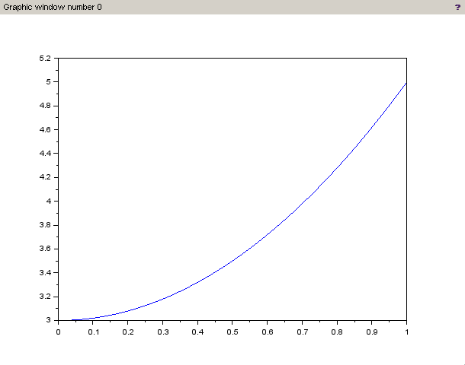

1. 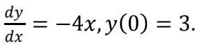

clc

clf

clear

function [**ydot**]=myfuntion(**x**, **y**)

**ydot** = -4\***x**

endfunction

x1 = 0

y1 = 3

x = linspace(0,1,100)

y = ode(y1, x1, x, myfuntion)

disp(x,y)

plot(x,y)

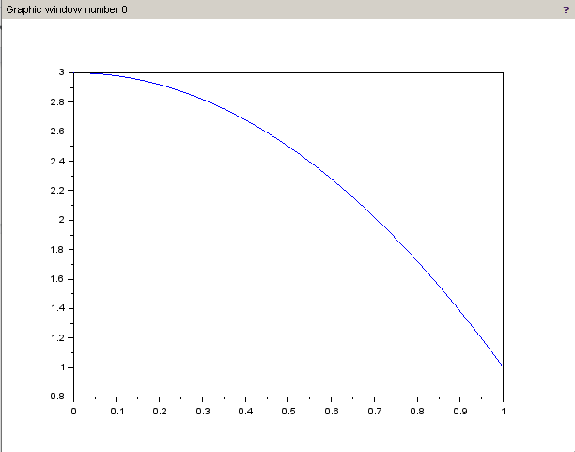

Date: 26/04/2022

clear

clc

clf

*//solution of y^2-5y^1+y=0*

function **dx**=f(**t**, **x**)

**dx**(1)=**x**(2)

**dx**(2)=(-1/2)\***x**(1)+5/2\***x**(2)

endfunction

sol=ode([6;-1],3,4,f)

*//disp(sol(1))*

t=4:.5:10;

sol=ode([6;-1],3,t,f)

plot(t,sol(1,:))

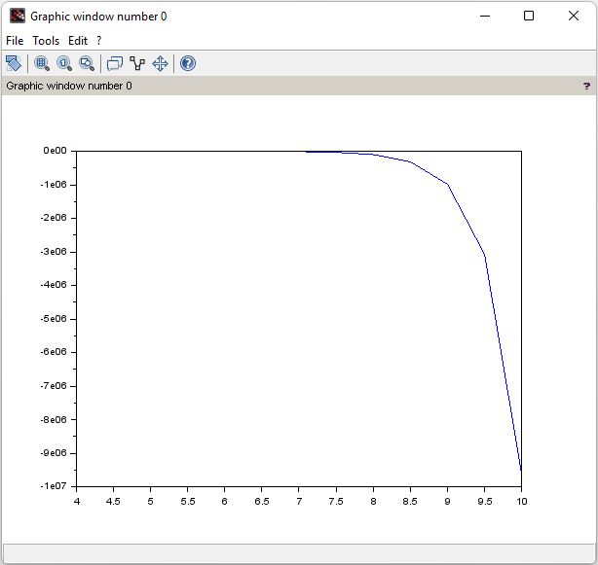

To be corrected:

clc

clear

clf

function **zdash**=f(**c**, **z**)

**zdash** = **c**\***z**

endfunction

c = [0 0 1; exp(x) -6 -5]

z = [1; 0; 1]

z0 = [0 1]

x = linspace(0,1,100)

y = ode( [0;1],0, x,f)

disp(x,y)

plot(x,y)

Date: 24/05/2022

Code for Fourier series

clc

clear

clf

deff('a=f(x)','a=x*x')

function [**a0**, **A**, **B**]=myfourier(**l**, **n**, **f**)

**a0** = (1/**l**)*integrate('f(x)','x',-**l**,**l**)

for i=1:**n**

function **an**=f1(**x**, **f**)

**an** = **f**(**x**)*cos(i*%pi\***x**/**l**)

endfunction

function **bn**=f2(**x**, **f**)

**bn** = **f**(**x**)*sin(i*%pi\***x**/l)

endfunction

A(i) = (1/l)*integrate('f1(x)','x',-l,l)

B(i) = (1/l)*integrate('f2(x)','x',-l,l)

end

x = -5*l:0.1:5*l

series = a0/2;

for i=1:n

series = series + A(i)*cos(i*%pi*x/l) + B(i)*sin(i*%pi*x/l)

end

plot(x,series)

endfunction

myfourier(2,6,f)

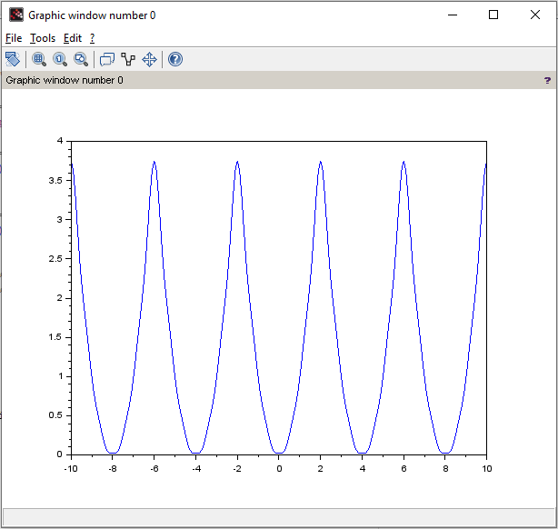

Write the SciLab code for the solution of one dimensional wave equation subjected to

u(0,t)=u(L,t)=0, with initial velocity zero, if the initial conditions for displacement is given by

f(x)= sin3x . Use the values of c=1, L=1. Also find the displacement in the string when x=0.5

and t=0.075

clc

clear

clf

l = input("Enter length of rod: ")

k = input("Enter value of coefficient k: ")

n = input("Enter number of terms required in solution: ")

function **w**=f(**x**)

**w** = sin(3*%pi\***x**)

endfunction

for i=1:n

function **w1**=f1(**x**)

**w1** = f(**x**)*sin(i*%pi\***x**/l)

endfunction

b(i) = (2/l)*integrate('f1(x)','x',0,l)

end

function **u**=f2(**x**, **t**)

**u**=0

for i=1:n

**u** = **u** + b(i)*sin(i*%pi\***x**/l)*cos(i*%pi*k\***t**/l)

end

endfunction

x = 0:0.05:1

t = 0:0.025:0.25

f1 = feval(x,t,f2)

plot3d(x,t,f1,'x@t@f2(x,t)')

scf(1)

plot(x',f1(:,1),'m.*',x',f1(:,3),'g.-',x',f1(:,6),'b.+',x',f1(:,9),'r.x')

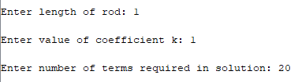

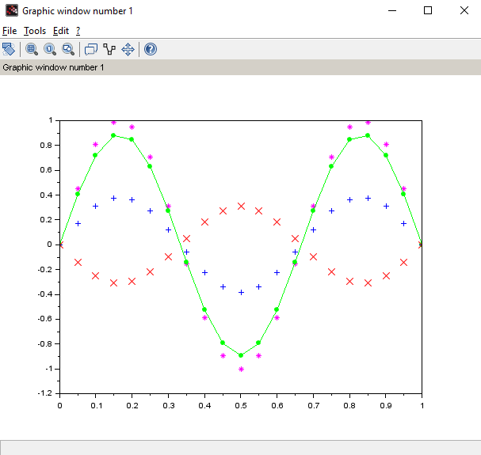

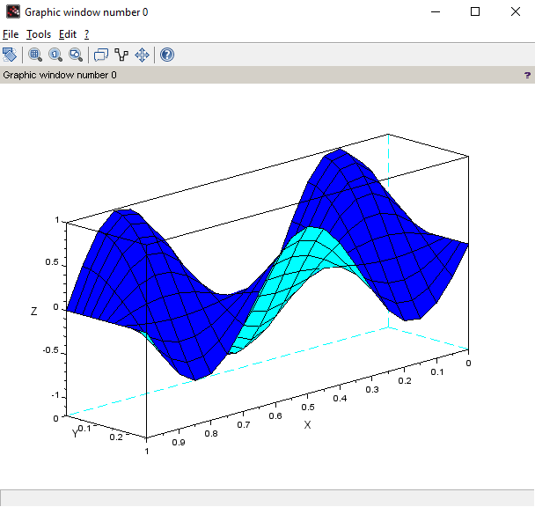

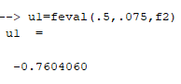

Date: 31/05/2022

**Write the SciLab code for the solution of one dimensional heat equation**

**subjected to u(0,t)=u(L,t)=0, if the initial conditions are given by u(x,0)=f(x)=4*(x/L)*(1-**

**x/L). Use the values of k=1, L=1. Also find the temperature in rod at x=0.4,t=0.2**

clc

clear

clf

l = input("Enter length of rod: ")

k = input("Enter value of coefficient k: ")

n = input("Enter number of terms required in solution: ")

function **w**=f(**x**)

**w** = 4\***x**/l*(1-**x**/l)

endfunction

for i=1:n

function **w1**=f1(**x**)

**w1** = f(**x**)*sin(i*%pi\***x**/l)

endfunction

b(i) = (2/l)*integrate('f1(x)','x',0,l)

end

function **u**=f2(**x**, **t**)

**u**=0

for i=1:n

**u** = **u** + b(i)*sin(i*%pi\***x**/l)*exp(-i^2*%pi^2*k\***t**/l^2)

end

endfunction

x = 0:0.05:1

t = 0:0.025:0.25

f1 = feval(x,t,f2)

plot3d(x,t,f1,'x@t@f2(x,t)')

scf(1)

plot(x',f1(:,1),'m.*',x',f1(:,3),'g.-',x',f1(:,6),'b.+',x',f1(:,9),'r.x')

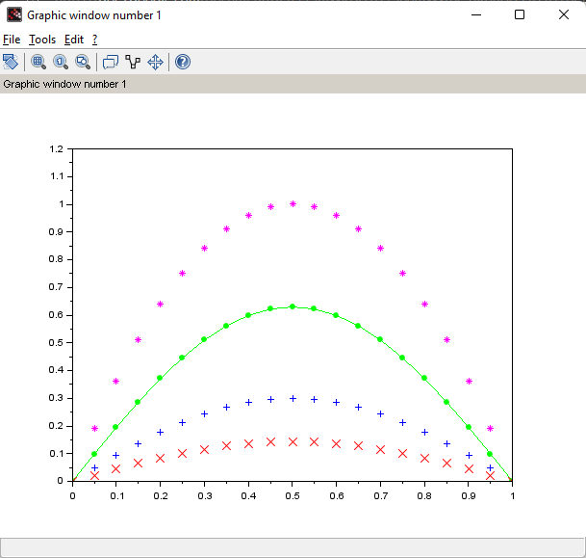

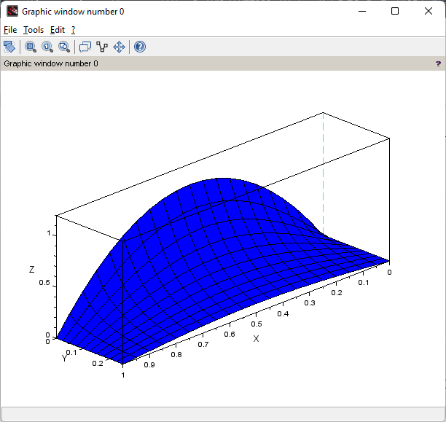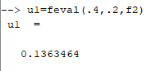

**Write the SciLab code for the solution of Two dimensional Laplace equation subjected to**

**u(x,0)=0, u(x,H)= 100*x*(L-x)^3, u(0,y)=u(L,y)=0. Use the values of H=1, L=2.**

clc

clear

clf

function **w**=f(**x**)

**w** = 100\***x**\*(l-**x**)^3

endfunction

function **w1**=f1(**x**)

**w1** = f(**x**)*sin(n*%pi\***x**/l)

endfunction

function **a**=a1(**n**)

**a** = 2*intg(0,l,f1,0.0001)/(l*sinh(**n**\*%pi*h/l))

endfunction

l=2

h = 1

a = []

for n=1:20

a = [a a1(n)]

end

function **u**=u1(**x**, **y**)

**u** = 0

for j=1:20

**u** = **u** + a(j)*sin(j*%pi\***x**/l)*sinh(j*%pi\***y**/l)

end

endfunction

x = 0:l/40:l;

y = 0:h/20:h;

u2 = feval(x,y,u1)

plot3d(x,y,u2,25,5,'x@t@u(x,t)')

scf(1)

contour(x,y,u2,15)

xtitle('Contour plots for Laplace equation','x','y')

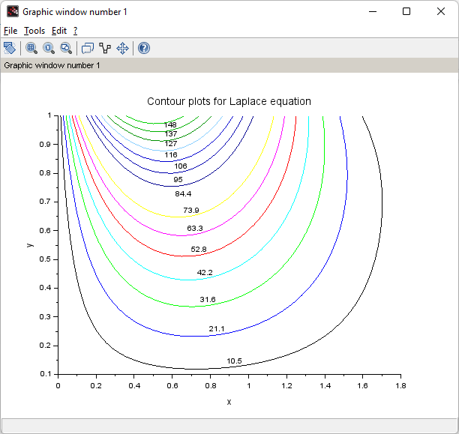

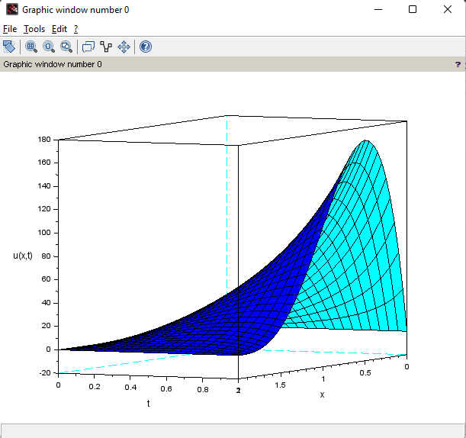

**To verify Rank theorem, rank+ nullity=No. of columns in the matrix, for an m X n matrix A.**

clc

clear

A = [4 5 9 -2; 6 5 1 12; 3 4 8 -3]

r = rank(A)

disp(r)

k = kernel(A)

nullity = size(k,2)

disp(nullity)

n = size(A,2)

disp(n)

if (r + nullity) == n then

disp("Rank Nullity Theorem Verified")

end

B = [2 5 -3 -4 8; 4 7 -4 -3 9; 6 9 -5 2 4; 0 -9 6 5 -6]

r = rank(B)

disp(r)

k = kernel(B)

nullity = size(k,2)

disp(nullity)

n = size(B,2)

disp(n)

if (r + nullity) == n then

disp("Rank Nullity Theorem Verified")

end

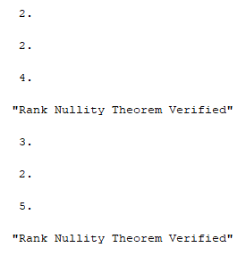

**For the system of linear equations: X+4y+7z=1, 2x+5y+8z=2, x+2y+3z=1**

**Does the solution exist?**

**How many free variables are there in solution?**

**Find the solution.**

clc

clear

A = [1 4 7; 2 5 8; 1 2 3]

*//X = [x1; x2; x3]*

B = [1; 2; 1]

X = inv(A)*B

disp(X)

k = kernel(A)

nullity = size(k,2)

disp(nullity)

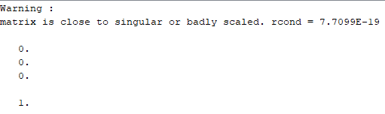

**Show that the set of vectors (2,2,1), (1,-1,1), (1,0,1) forms a basis for space R3 ?**

**(ii)Find the coordinates of the vector (4,2,1) w.r.t. the basis set given in (i)**

clc

clear

A = [2 1 1; 2 -1 0; 1 1 1]

*//X = [x1; x2; x3]*

B = [4; 3; 1]

X = inv(A)*B

disp(X)

X = inv(A')*B

disp(X)

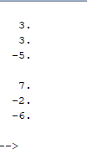

Date: 07/06/2022

**To write a script file for Gram-Schmidt orthogonalization process.**

clc

clear

u1 = [3 0 4]

u2 = [-1 0 7]

u3 = [2 9 11]

U = [u1; u2; u3]

[r, c] = size(U)

*//[m n]= size (a);*

q = zeros (r,c);

r = zeros (c,c);

for j=1: c

v= U(:,j)

for i =1:j -1

r(i,j)=q(:,i)'*U(:,j)

v=v-r(i,j)*q(:,i)

end

r(j,j)= norm(v)

q(:,j)=v/r(j,j)

disp(v, ' v=' )

disp(q, ' q=' )

end

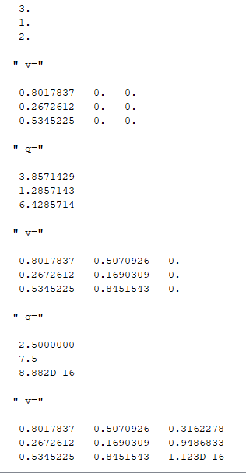

2. **Determine if the following set of vectors form an orthogonal basis for**

**R2 with the standard inner product. u=(2,5,-1), v=(-2,1,1)**

clc

clear

u = [2 5 -1]

v = [-2;1;1]

V = u * v

disp(V)

if V == 0 then

disp("It is orthogonal")

else

disp("It is not orthogonal")

end

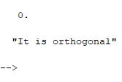

**Find orthonormal basis in part (ii)**

clc

clear

u = [2;5;-1]

v = [-2;1;1]

w1 = u / norm(u)

disp(w1)

w2 = v / norm(v)

disp(w2)

